## Nework animation

## DNS Animation

## How to Download Momentum Wallpapers

Open New Tab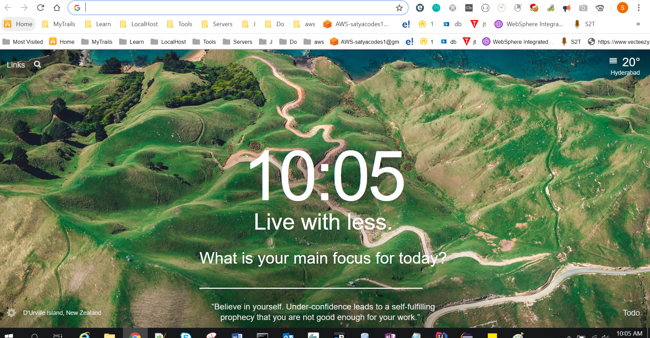

Right Click > Inspect 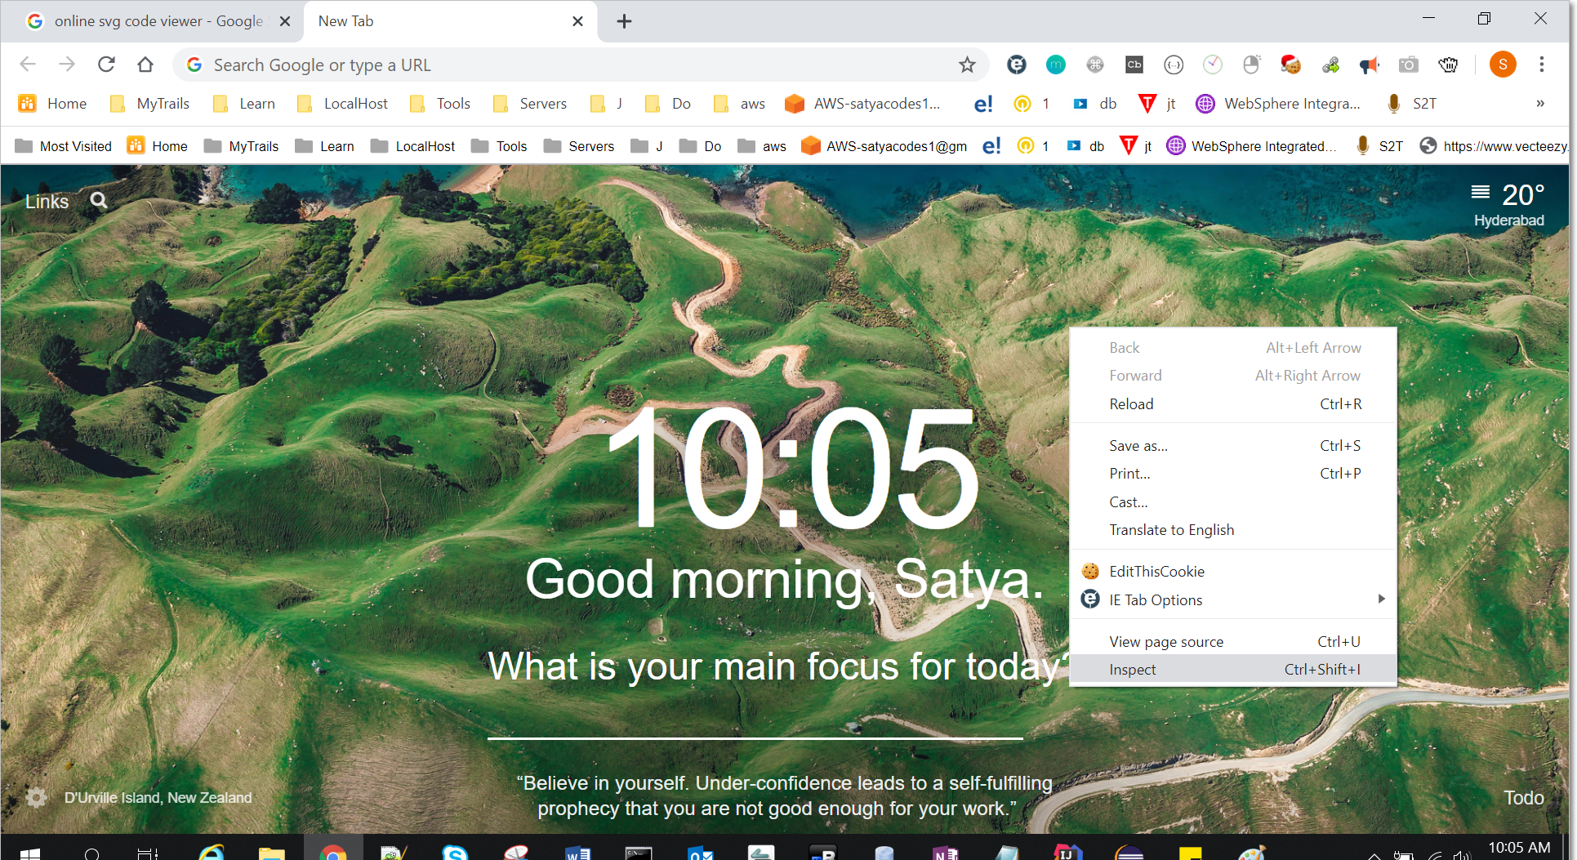

You will Find

<ul id="background" class="background">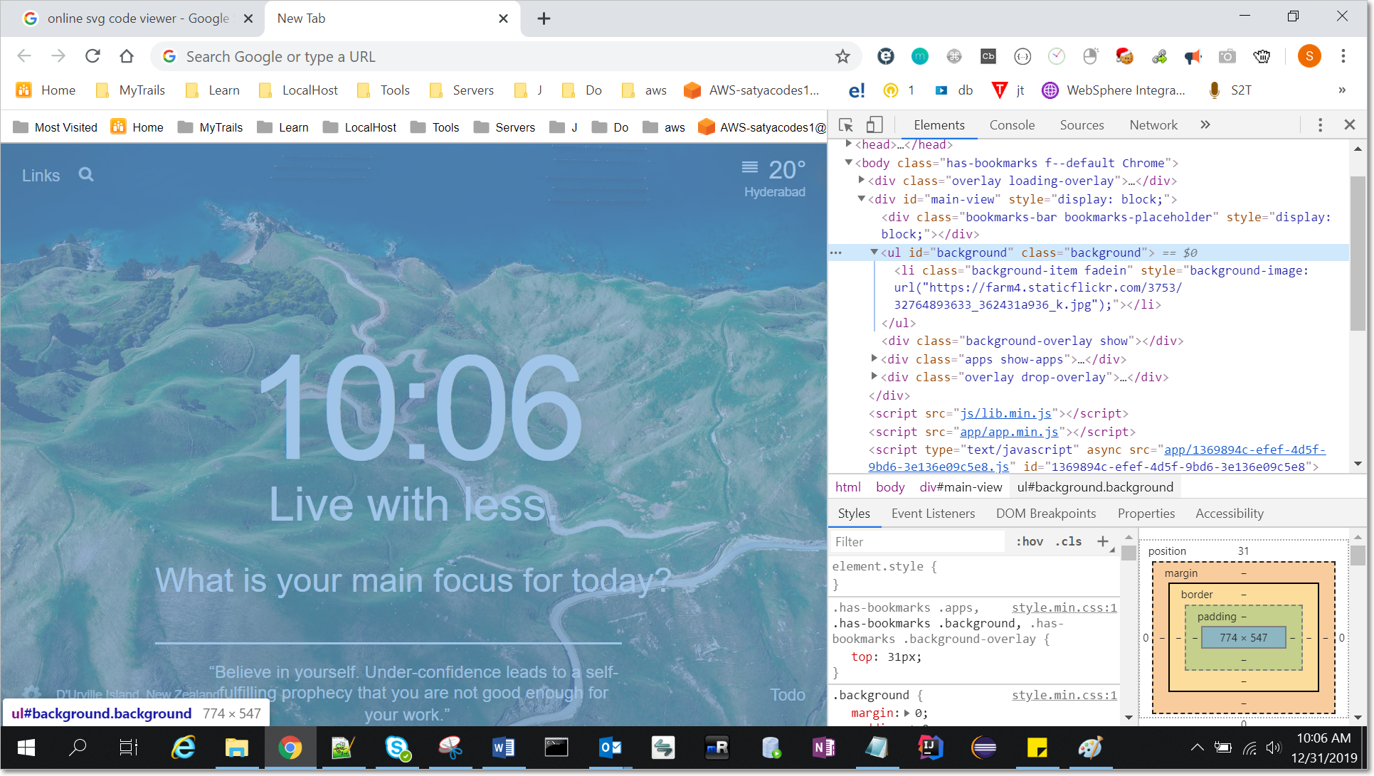

Open URL inside <li> tag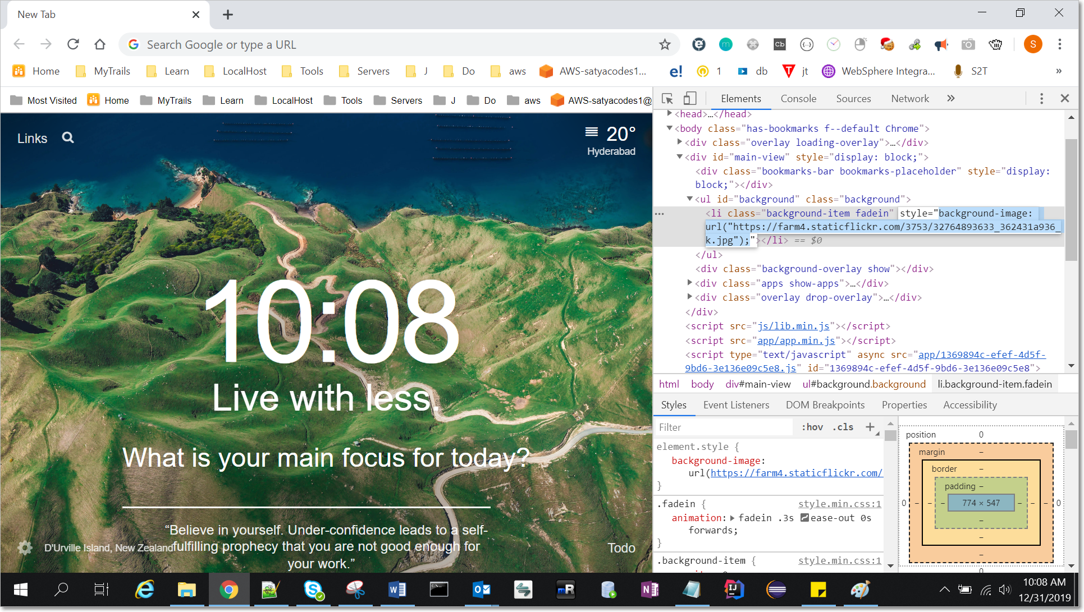

[https://farm4.staticflickr.com/3753/32764893633_362431a936_k.jpg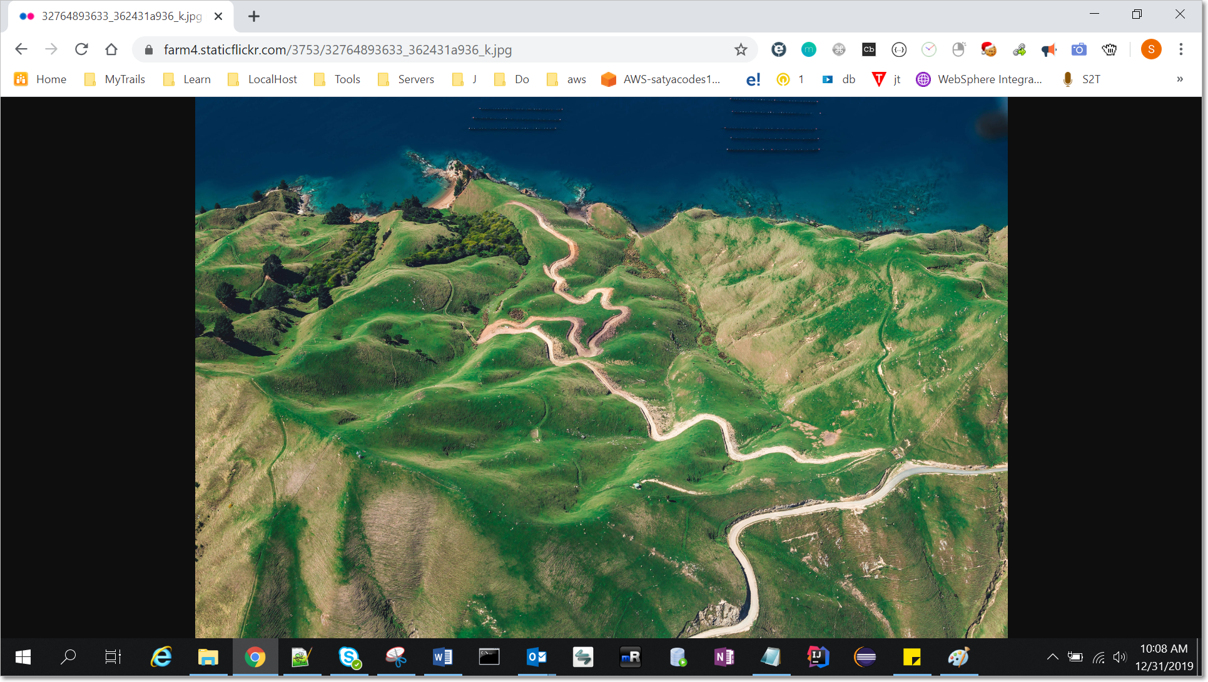](https://farm4.staticflickr.com/3753/32764893633_362431a936_k.jpg)

That’s It!!!

## How to Split Word Document by Heading

1.Open Word document you want to Split

2.Goto View > Macros > View Macros > Create : Provide macro name then Create

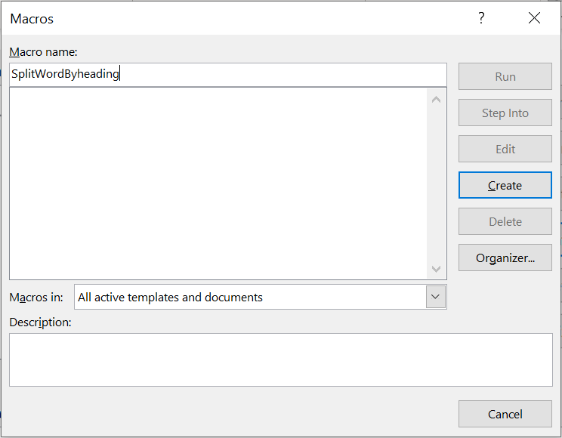

3.Copy & paste below code – save.

Option Explicit

Sub SeperateHeadings()

Dim TotalLines As Long

Dim x As Long

Dim Groups() As Long

Dim Counter As Long

Dim y As Long

Dim FilePath As String

Dim FileName() As String

FilePath = ActiveDocument.Path

Selection.GoTo What:=wdGoToLine, Which:=wdGoToAbsolute, Count:=1

Do

TotalLines = Selection.Range.Information(wdFirstCharacterLineNumber)

Selection.MoveDown Unit:=wdLine, Count:=1

Loop While TotalLines <> Selection.Range.Information(wdFirstCharacterLineNumber)

Selection.GoTo What:=wdGoToLine, Which:=wdGoToAbsolute, Count:=1

For x = 1 To TotalLines

If Selection.Style = "Heading 1" Then

Counter = Counter + 1

ReDim Preserve Groups(1 To Counter)

ReDim Preserve FileName(1 To Counter)

Groups(Counter) = x

Selection.EndKey Unit:=wdLine, Extend:=wdExtend

FileName(Counter) = Selection.Text

FileName(Counter) = Left(Selection.Text, Len(FileName(Counter)) - 1)

Selection.HomeKey Unit:=wdLine, Extend:=wdExtend

End If

Selection.MoveDown Unit:=wdLine, Count:=1

Next

Counter = Counter + 1

ReDim Preserve Groups(1 To Counter)

Groups(Counter) = TotalLines

For x = 1 To UBound(Groups) - 1

y = Groups(x + 1) - Groups(x)

Selection.GoTo What:=wdGoToLine, Which:=wdGoToAbsolute, Count:=Groups(x)

Selection.MoveDown Unit:=wdLine, Count:=y, Extend:=wdExtend

Selection.Copy

Documents.Add

Selection.Paste

ActiveDocument.SaveAs FilePath & "\" & FileName(x) & ".doc"

ActiveDocument.Close

Next x

End Sub



Save & Close the VB Editor.

2. To run Macro – Goto View > Macros > View Macros > Select Macro to Run > Run